**ASSIGNMENT 1**

SDLC Overview - Create a one-page info graphic that outlines the SDLC phases (Requirements, Design, Implementation, Testing, Deployment), highlighting the importance of each phase and how they interconnect.

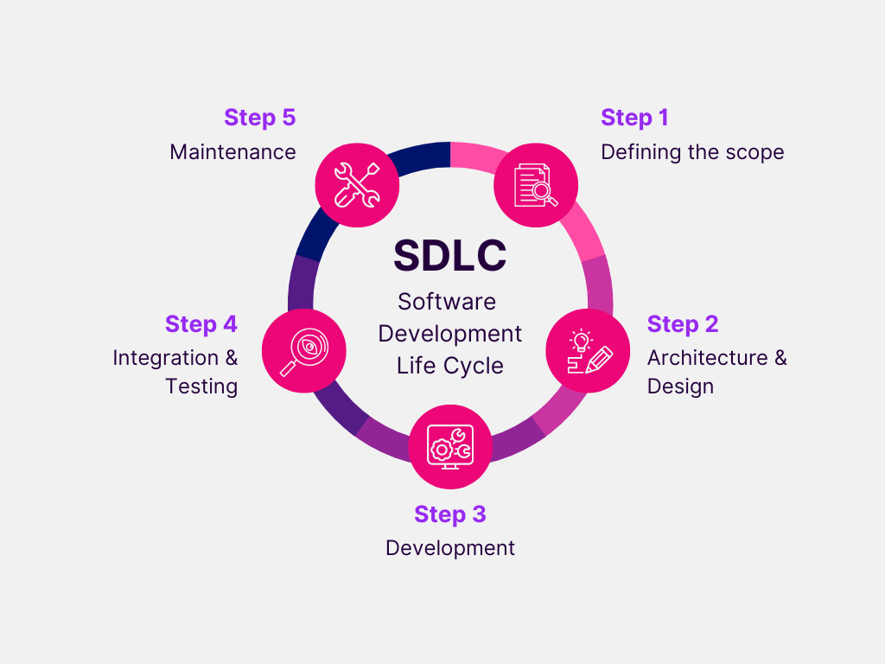

**1. Requirements Gathering**

* **Importance**: This phase involves understanding and documenting the system’s functional and non-functional requirements. It’s crucial as it sets the foundation for the entire project.
* **Interconnection**: The output of this phase serves as an input to the Design phase.

**2. Design**

* **Importance**: In this phase, the system’s architecture is designed based on the requirements. It’s important as it provides a road map for the developers in the Implementation phase.
* **Interconnection**: The design documents guide the Implementation phase, and the testing strategy for the Testing phase is also prepared.

**3. Implementation**

* **Importance**: This phase involves coding and developing the software based on the design. It’s crucial as it brings the design to life.
* **Interconnection**: The output of this phase, the software product, is what gets tested in the Testing phase.

**4. Testing**

* **Importance**: This phase involves identifying and fixing bugs in the software product. It’s important as it ensures the product is error-free and works as expected.
* **Interconnection**: The tested and refined software product is then ready for the Deployment phase.

**5. Deployment**

* **Importance**: In this phase, the software product is deployed and made available to the end-users. It’s crucial as it marks the delivery of the product to the client.
* **Interconnection**: Post-deployment, any issues or changes are noted for the next cycle, taking us back to the Requirements phase.